Department of Planning in collaboration with the Purchasing Division

*Presents the*

**Affordable Housing Real Estate Developers**

**Meet & Greet**

Baltimore County Public Library

Owings Mills Branch

 10302 Grand Central Ave

Conference Rooms A,B and C

              Owings Mills, MD 21117

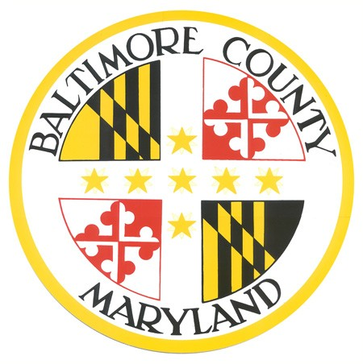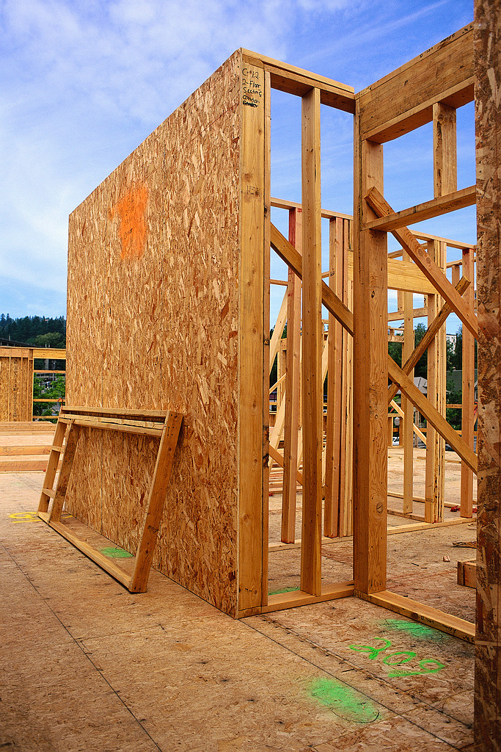

Thursday, August 7, 2014

10 AM to 1 PM

Cost: **FREE**

The Department of Planning in collaboration with the Baltimore County Purchasing Division cordially invites you to participate as an exhibitor in the upcoming Real Estate Developers Meet and Greet as the County endeavors to achieve its minority participation goal.

The purpose of this event is to provide a venue for Developers to share engage in business discussions with the local minority-owned (MBE), women-owned (WBE) and other small businesses potential upcoming subcontracting opportunities and requirements.

Potential subcontractors come prepared with a one page capability statement outlining the company’s contact information, past experience in your field of expertise with government (or commercial), licenses and/or certifications obtained, NAICS code with description: **238910 - MBE/DBE/SBE - SITE PREPARATION CONTRACTORS**.

To register for this event visit: <http://www.eventbrite.com/e/baltimore-county-affordable-housing-real-estate-developers-meet-and-greet-tickets-12164517399>

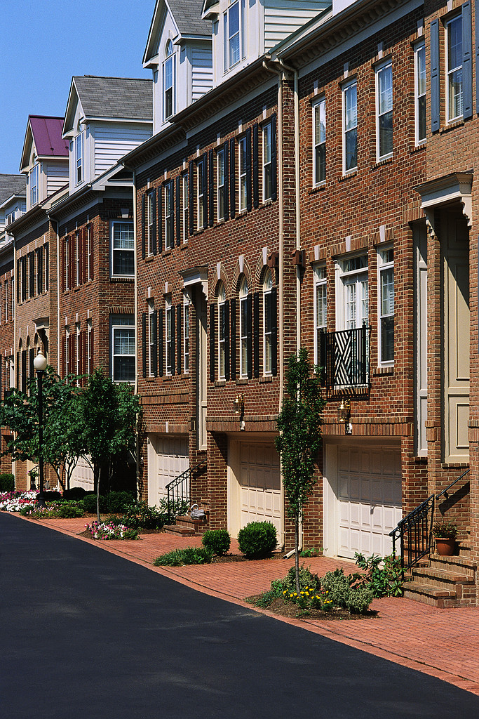

Marcia Williams  
Housing Program Administrator Neighborhood Improvement

Email:[mdwilliams@baltimorecountymd.gov](mailto:mdwilliams@baltimorecountymd.gov)

Phone: 410.887.3803

Carla Tucker

Minority and Small Business Marketing Manager, Purchasing Division

Email: [ctucker@baltimorecountymd.gov](mailto:ctucker@baltimorecountymd.gov)

Phone: 410.887.3119

In partnership with the Maryland Department of Housing and Community Development.

